32.8: 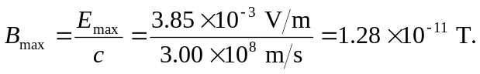
So 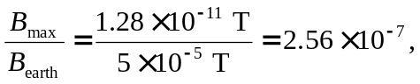and thus 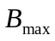is much weaker than 